4-Bit Digital Tube  
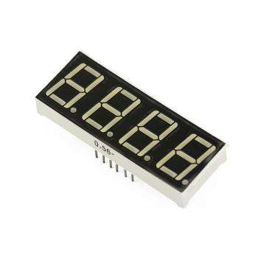

Overview

“4-Bit Digital Tube” is the conventional name for a display capable of showing four numeric digits, where any possible digit, in turn, is composed of up to seven separate LED segments. (A decimal point potentially trailing each digit represents an eighth possible LED in that digit display.) Such low-cost, low-power numeric displays are common in microwave ovens, alarm clocks, induction cookers, automatic washing machines, and similar devices. In this experiment, you’ll program the Raspberry Pi to show the digits 0 through 9, sequentially, on the LED display.

Materials Needed

Raspberry Pi x1

Breadboard x1

4-Bit Digital Tube x1

150Ω-330Ω resistors x8 (you provide)

Dupont jumper wires

Experimental Procedure

1. If you have not done so already, prepare your development system by installing the Python interpreter, RPi.GIO library, and wiringPi library as described in READ_ME.TXT.
2. Install the 4-digit 8-segment LED display on your breadboard, and use Dupont jumper wires and resistors to connect it to your Raspberry Pi as illustrated in the Wiring Diagram below. The resistors connect to the eight LED pins (**A**-**G**, **DP**) and protect them from the current of the Raspberry Pi GPIO pins. The other four pins (**1-4**) do not connect to fragile LEDs and therefore do not need resistors.
3. Execute the sample stored in this experiment’s subfolder.

If using C, compile and execute the C code:  
cd Code/C  
gcc 8segment_4digit.c -o 8segment_4digit.out –lwiringPi  
./8segment_4digit.out

If using Python, launch the Python script:  
cd Code/Python  
python 8segment_4digit.py

1. Make experimental observations.  
   The multidigit LED display shows the digts “1234” in a cycle.

Wiring Diagram

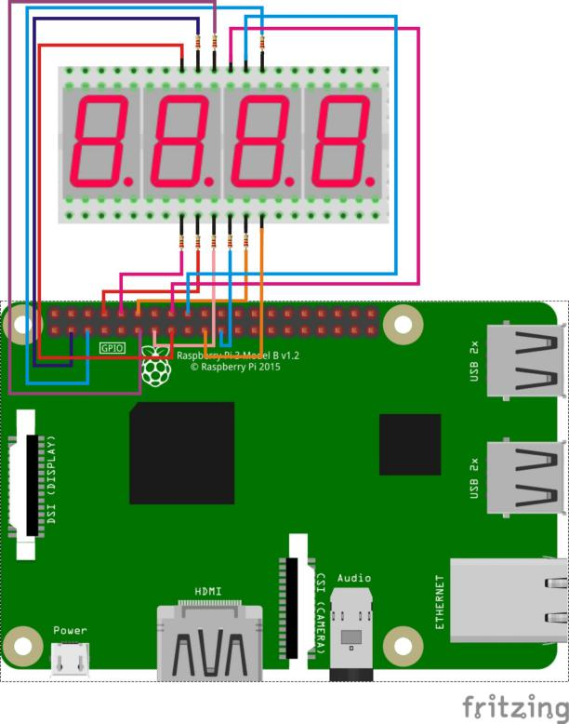

4bit_digital_tube pin position:

'A' ↔ Raspberry Pi pin 3

'B' ↔ Raspberry Pi pin 5

'C' ↔ Raspberry Pi pin 21

'D' ↔ Raspberry Pi pin 8

'E' ↔ Raspberry Pi pin 10

'F' ↔ Raspberry Pi pin 11

'G' ↔ Raspberry Pi pin 12

'DP' ↔ Raspberry Pi pin 13

'1' ↔ Raspberry Pi pin 15

'2' ↔ Raspberry Pi pin 16

'3' ↔ Raspberry Pi pin 18

'4' ↔ Raspberry Pi pin 19

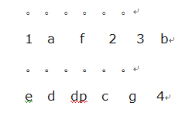

Technical Background

◆ Model: common anode

◆ Size: length 30mm* width 14mm* thickness 7.2mm

◆ lighting color: bright red

Sample Code

Python code

#!/usr/bin/env python

import RPi.GPIO as GPIO

import time

pins = {'pinA':3, 'pinB':5, 'pinC':21, 'pinD':8, 'pinE':10, 'pinF':11, 'pinG':12, 'pinDP':13, 'pin_1':15, 'pin_2':16, 'pin_3':18, 'pin_4':19}

def init():

GPIO.setmode(GPIO.BOARD)

for i in pins:

GPIO.setup(pins[i], GPIO.OUT)

print 'gpio init completed!'

def bitSelect(bitNum):

if(bitNum == 1):

GPIO.output(pins['pin_1'], GPIO.HIGH)

GPIO.output(pins['pin_2'], GPIO.LOW)

GPIO.output(pins['pin_3'], GPIO.LOW)

GPIO.output(pins['pin_4'], GPIO.LOW)

elif(bitNum == 2):

GPIO.output(pins['pin_1'], GPIO.LOW)

GPIO.output(pins['pin_2'], GPIO.HIGH)

GPIO.output(pins['pin_3'], GPIO.LOW)

GPIO.output(pins['pin_4'], GPIO.LOW)

elif(bitNum == 3):

GPIO.output(pins['pin_1'], GPIO.LOW)

GPIO.output(pins['pin_2'], GPIO.LOW)

GPIO.output(pins['pin_3'], GPIO.HIGH)

GPIO.output(pins['pin_4'], GPIO.LOW)

elif(bitNum == 4):

GPIO.output(pins['pin_1'], GPIO.LOW)

GPIO.output(pins['pin_2'], GPIO.LOW)

GPIO.output(pins['pin_3'], GPIO.LOW)

GPIO.output(pins['pin_4'], GPIO.HIGH)

else:

GPIO.output(pins['pin_1'], GPIO.LOW)

GPIO.output(pins['pin_2'], GPIO.LOW)

GPIO.output(pins['pin_3'], GPIO.LOW)

GPIO.output(pins['pin_4'], GPIO.LOW)

print 'bitSelect completed!'

def display_0():

GPIO.output(pins['pinA'], GPIO.LOW)

GPIO.output(pins['pinB'], GPIO.LOW)

GPIO.output(pins['pinC'], GPIO.LOW)

GPIO.output(pins['pinD'], GPIO.LOW)

GPIO.output(pins['pinE'], GPIO.LOW)

GPIO.output(pins['pinF'], GPIO.LOW)

GPIO.output(pins['pinG'], GPIO.HIGH)

GPIO.output(pins['pinDP'], GPIO.HIGH)

print 'display number 0'

def display_1():

GPIO.output(pins['pinA'], GPIO.HIGH)

GPIO.output(pins['pinB'], GPIO.LOW)

GPIO.output(pins['pinC'], GPIO.LOW)

GPIO.output(pins['pinD'], GPIO.HIGH)

GPIO.output(pins['pinE'], GPIO.HIGH)

GPIO.output(pins['pinF'], GPIO.HIGH)

GPIO.output(pins['pinG'], GPIO.HIGH)

GPIO.output(pins['pinDP'], GPIO.HIGH)

print 'display number 1'

def display_2():

GPIO.output(pins['pinA'], GPIO.LOW)

GPIO.output(pins['pinB'], GPIO.LOW)

GPIO.output(pins['pinC'], GPIO.HIGH)

GPIO.output(pins['pinD'], GPIO.LOW)

GPIO.output(pins['pinE'], GPIO.LOW)

GPIO.output(pins['pinF'], GPIO.HIGH)

GPIO.output(pins['pinG'], GPIO.LOW)

GPIO.output(pins['pinDP'], GPIO.HIGH)

print 'display number 2'

def display_3():

GPIO.output(pins['pinA'], GPIO.LOW)

GPIO.output(pins['pinB'], GPIO.LOW)

GPIO.output(pins['pinC'], GPIO.LOW)

GPIO.output(pins['pinD'], GPIO.LOW)

GPIO.output(pins['pinE'], GPIO.HIGH)

GPIO.output(pins['pinF'], GPIO.HIGH)

GPIO.output(pins['pinG'], GPIO.LOW)

GPIO.output(pins['pinDP'], GPIO.HIGH)

print 'display number 3'

def display_4():

GPIO.output(pins['pinA'], GPIO.HIGH)

GPIO.output(pins['pinB'], GPIO.LOW)

GPIO.output(pins['pinC'], GPIO.LOW)

GPIO.output(pins['pinD'], GPIO.HIGH)

GPIO.output(pins['pinE'], GPIO.HIGH)

GPIO.output(pins['pinF'], GPIO.LOW)

GPIO.output(pins['pinG'], GPIO.LOW)

GPIO.output(pins['pinDP'], GPIO.HIGH)

print 'display number 4'

def display_5():

GPIO.output(pins['pinA'], GPIO.LOW)

GPIO.output(pins['pinB'], GPIO.HIGH)

GPIO.output(pins['pinC'], GPIO.LOW)

GPIO.output(pins['pinD'], GPIO.LOW)

GPIO.output(pins['pinE'], GPIO.HIGH)

GPIO.output(pins['pinF'], GPIO.LOW)

GPIO.output(pins['pinG'], GPIO.LOW)

GPIO.output(pins['pinDP'], GPIO.HIGH)

print 'display number 5'

def display_6():

GPIO.output(pins['pinA'], GPIO.LOW)

GPIO.output(pins['pinB'], GPIO.HIGH)

GPIO.output(pins['pinC'], GPIO.LOW)

GPIO.output(pins['pinD'], GPIO.LOW)

GPIO.output(pins['pinE'], GPIO.LOW)

GPIO.output(pins['pinF'], GPIO.LOW)

GPIO.output(pins['pinG'], GPIO.LOW)

GPIO.output(pins['pinDP'], GPIO.HIGH)

print 'display number 6'

def display_7():

GPIO.output(pins['pinA'], GPIO.LOW)

GPIO.output(pins['pinB'], GPIO.LOW)

GPIO.output(pins['pinC'], GPIO.LOW)

GPIO.output(pins['pinD'], GPIO.HIGH)

GPIO.output(pins['pinE'], GPIO.HIGH)

GPIO.output(pins['pinF'], GPIO.HIGH)

GPIO.output(pins['pinG'], GPIO.HIGH)

GPIO.output(pins['pinDP'], GPIO.HIGH)

print 'display number 7'

def display_8():

GPIO.output(pins['pinA'], GPIO.LOW)

GPIO.output(pins['pinB'], GPIO.LOW)

GPIO.output(pins['pinC'], GPIO.LOW)

GPIO.output(pins['pinD'], GPIO.LOW)

GPIO.output(pins['pinE'], GPIO.LOW)

GPIO.output(pins['pinF'], GPIO.LOW)

GPIO.output(pins['pinG'], GPIO.LOW)

GPIO.output(pins['pinDP'], GPIO.HIGH)

print 'display number 8'

def display_9():

GPIO.output(pins['pinA'], GPIO.LOW)

GPIO.output(pins['pinB'], GPIO.LOW)

GPIO.output(pins['pinC'], GPIO.LOW)

GPIO.output(pins['pinD'], GPIO.LOW)

GPIO.output(pins['pinE'], GPIO.HIGH)

GPIO.output(pins['pinF'], GPIO.LOW)

GPIO.output(pins['pinG'], GPIO.LOW)

GPIO.output(pins['pinDP'], GPIO.HIGH)

print 'display number 9'

def display_dp():

GPIO.output(pins['pinA'], GPIO.HIGH)

GPIO.output(pins['pinB'], GPIO.HIGH)

GPIO.output(pins['pinC'], GPIO.HIGH)

GPIO.output(pins['pinD'], GPIO.HIGH)

GPIO.output(pins['pinE'], GPIO.HIGH)

GPIO.output(pins['pinF'], GPIO.HIGH)

GPIO.output(pins['pinG'], GPIO.HIGH)

GPIO.output(pins['pinDP'], GPIO.LOW)

print 'display DP'

def clear(): #clear the screen

GPIO.output(pins['pinA'], GPIO.HIGH)

GPIO.output(pins['pinB'], GPIO.HIGH)

GPIO.output(pins['pinC'], GPIO.HIGH)

GPIO.output(pins['pinD'], GPIO.HIGH)

GPIO.output(pins['pinE'], GPIO.HIGH)

GPIO.output(pins['pinF'], GPIO.HIGH)

GPIO.output(pins['pinG'], GPIO.HIGH)

GPIO.output(pins['pinDP'], GPIO.HIGH)

print 'clear the screen!'

def pickNum(number):

if(number == 0):

display_0()

elif(number == 1):

display_1()

elif(number == 2):

display_2()

elif(number == 3):

display_3()

elif(number == 4):

display_4()

elif(number == 5):

display_5()

elif(number == 6):

display_6()

elif(number == 7):

display_7()

elif(number == 8):

display_8()

elif(number == 9):

display_9()

else:

clear()

def Display(Bit, Number):

bitSelect(Bit)

pickNum(Number)

time.sleep(0.001)

def loop():

while True:

Display(1,1)

time.sleep(1)

Display(2,2)

time.sleep(1)

Display(3,3)

time.sleep(1)

Display(4,4)

time.sleep(1)

if __name__ == '__main__':

try:

init()

loop()

except KeyboardInterrupt:

GPIO.cleanup()

print 'Key Board Interrupt!'

2. C Code

#include <wiringPi.h>

#include <stdio.h>

//display 1234

//Set cathode interface

int a = 8;

int b = 9;

int c = 13;

int d = 15;

int e = 16;

int f = 0;

int g = 1;

int dp = 2;

//Set anode interface

int d4 = 12;

int d3 = 5;

int d2 = 4;

int d1 = 3;

//Set variable

long n = 1230;

int x = 100;

int del = 55; //Here to fine tune the clock

void init()

{

pinMode(d1, OUTPUT);

pinMode(d2, OUTPUT);

pinMode(d3, OUTPUT);

pinMode(d4, OUTPUT);

pinMode(a, OUTPUT);

pinMode(b, OUTPUT);

pinMode(c, OUTPUT);

pinMode(d, OUTPUT);

pinMode(e, OUTPUT);

pinMode(f, OUTPUT);

pinMode(g, OUTPUT);

pinMode(dp, OUTPUT);

}

void bitSelect(unsigned char n)//

{

switch(n)

{

case 1:

digitalWrite(d1,HIGH);

digitalWrite(d2, LOW);

digitalWrite(d3, LOW);

digitalWrite(d4, LOW);

break;

case 2:

digitalWrite(d1, LOW);

digitalWrite(d2, HIGH);

digitalWrite(d3, LOW);

digitalWrite(d4, LOW);

break;

case 3:

digitalWrite(d1,LOW);

digitalWrite(d2, LOW);

digitalWrite(d3, HIGH);

digitalWrite(d4, LOW);

break;

case 4:

digitalWrite(d1, LOW);

digitalWrite(d2, LOW);

digitalWrite(d3, LOW);

digitalWrite(d4, HIGH);

break;

default :

digitalWrite(d1, LOW);

digitalWrite(d2, LOW);

digitalWrite(d3, LOW);

digitalWrite(d4, LOW);

break;

}

}

void Num_0()

{

digitalWrite(a, LOW);

digitalWrite(b, LOW);

digitalWrite(c, LOW);

digitalWrite(d, LOW);

digitalWrite(e, LOW);

digitalWrite(f, LOW);

digitalWrite(g, HIGH);

digitalWrite(dp,HIGH);

}

void Num_1()

{

digitalWrite(a, HIGH);

digitalWrite(b, LOW);

digitalWrite(c, LOW);

digitalWrite(d, HIGH);

digitalWrite(e, HIGH);

digitalWrite(f, HIGH);

digitalWrite(g, HIGH);

digitalWrite(dp,HIGH);

}

void Num_2()

{

digitalWrite(a, LOW);

digitalWrite(b, LOW);

digitalWrite(c, HIGH);

digitalWrite(d, LOW);

digitalWrite(e, LOW);

digitalWrite(f, HIGH);

digitalWrite(g, LOW);

digitalWrite(dp,HIGH);

}

void Num_3()

{

digitalWrite(a, LOW);

digitalWrite(b, LOW);

digitalWrite(c, LOW);

digitalWrite(d, LOW);

digitalWrite(e, HIGH);

digitalWrite(f, HIGH);

digitalWrite(g, LOW);

digitalWrite(dp,HIGH);

}

void Num_4()

{

digitalWrite(a, HIGH);

digitalWrite(b, LOW);

digitalWrite(c, LOW);

digitalWrite(d, HIGH);

digitalWrite(e, HIGH);

digitalWrite(f, LOW);

digitalWrite(g, LOW);

digitalWrite(dp,HIGH);

}

void Num_5()

{

digitalWrite(a, LOW);

digitalWrite(b, HIGH);

digitalWrite(c, LOW);

digitalWrite(d, LOW);

digitalWrite(e, HIGH);

digitalWrite(f, LOW);

digitalWrite(g, LOW);

digitalWrite(dp,HIGH);

}

void Num_6()

{

digitalWrite(a, LOW);

digitalWrite(b, HIGH);

digitalWrite(c, LOW);

digitalWrite(d, LOW);

digitalWrite(e, LOW);

digitalWrite(f, LOW);

digitalWrite(g, LOW);

digitalWrite(dp,HIGH);

}

void Num_7()

{

digitalWrite(a, LOW);

digitalWrite(b, LOW);

digitalWrite(c, LOW);

digitalWrite(d, HIGH);

digitalWrite(e, HIGH);

digitalWrite(f, HIGH);

digitalWrite(g, HIGH);

digitalWrite(dp,HIGH);

}

void Num_8()

{

digitalWrite(a, LOW);

digitalWrite(b, LOW);

digitalWrite(c, LOW);

digitalWrite(d, LOW);

digitalWrite(e, LOW);

digitalWrite(f, LOW);

digitalWrite(g, LOW);

digitalWrite(dp,HIGH);

}

void Num_9()

{

digitalWrite(a, LOW);

digitalWrite(b, LOW);

digitalWrite(c, LOW);

digitalWrite(d, LOW);

digitalWrite(e, HIGH);

digitalWrite(f, LOW);

digitalWrite(g, LOW);

digitalWrite(dp,HIGH);

}

void Clear() // Clear the screen

{

digitalWrite(a, HIGH);

digitalWrite(b, HIGH);

digitalWrite(c, HIGH);

digitalWrite(d, HIGH);

digitalWrite(e, HIGH);

digitalWrite(f, HIGH);

digitalWrite(g, HIGH);

digitalWrite(dp,HIGH);

}

void pickNumber(unsigned char n)//Choose the number of

{

switch(n)

{

case 0:Num_0();

break;

case 1:Num_1();

break;

case 2:Num_2();

break;

case 3:Num_3();

break;

case 4:Num_4();

break;

case 5:Num_5();

break;

case 6:Num_6();

break;

case 7:Num_7();

break;

case 8:Num_8();

break;

case 9:Num_9();

break;

default:Clear();

break;

}

}

void Display(unsigned char x, unsigned char Number)//Show that x is the coordinate, Number is the number

{

bitSelect(x);

pickNumber(Number);

delay(1);

//Clear() ; //Vanishing

}

int main(void)

{

if(wiringPiSetup() == -1)

{

printf("wiringPi setup failed!\n");

return -1;

}

init();

while(1)

{

Display(1, 1);

delay(1000);

Display(2, 2);

delay(1000);

Display(3, 3);

delay(1000);

Display(4, 4);

delay(1000);

}

}